Placement Dataset Measures of Central Tendencies Report

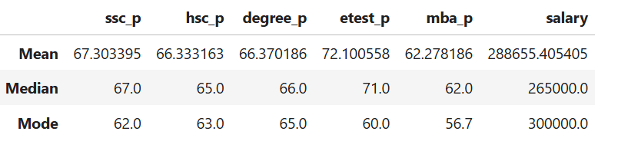

ssc_p (Secondary Percentage)
Mean ≈ 67.3
Median = 67
Mode = 62
Descriptive Analysis:
Most students scored above 65%.

hsc_p (Higher Secondary Percentage)
Mean ≈ 66.3
Median = 65
Mode = 63
Descriptive Analysis:
Most students scored above 65% but lower than ssc_p.

degree_p (Degree Percentage)
Mean ≈ 66.4
Median = 66
Mode = 65
Descriptive Analysis:
Most students scored above 65% but lower than ssc_p and higher than hsc_p.
etest_p (Entrance Test)
Mean ≈ 72.1
Median = 71
Mode = 60
Descriptive Analysis:
Mean > median
Most students scored above 70% which is higher than ssc_p, hsc_p, degree_p, mba_p.
Mode is lower than ssc_p, hsc_p, degree_p, mba_p. Many students scored 60%.
mba_p (MBA Percentage)
Mean ≈ 62.3
Median = 62
Mode ≈ 56.7
Descriptive Analysis:
Most students scored above 62% which is lower than ssc_p, hsc_p, degree_p, etest_p.
salary
Mean ≈ 288,655
Median = 265,000
Mode = 300,000
Descriptive Analysis:
Median is the most reliable measure since it omits outliers (extreme salary/very low salary). Mode 300,000 suggests the most common salary.

